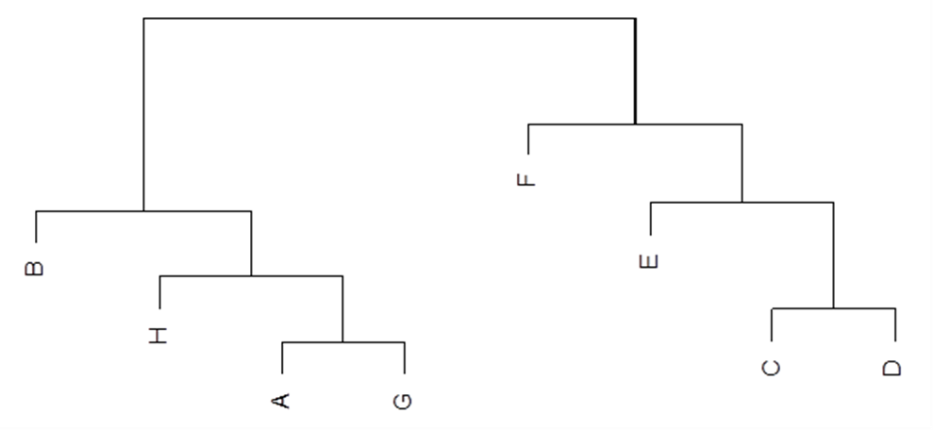

Figure 1. Visualization of hierarchical clustering results with the use of dendrogram
Source: own research

