Diagram 1. The selection process for the analyzed articles
Rejected publications
(n=454)
Publications assessed
based on the full text
(n=55)
Publication selected based on citations
(n=56)
Publications assessed
based on abstracts and keywords (n=510)
Rejected publications
(n=546)
Publications after introducing an additional criterion: keyword leadership (n=1056)
Publications from 2010-2020
selected acc. to criteria (n=3736)
Publications on leadership
identified in the Scopus database
acc. to the keyword leadership (n=114802)

Source: own work based on BMJ 2021; 372: n71 http://dx.doi.org/10.1136/bmj.n71 ; pp. 1-9, p.3.

Figure 1. Publications on leadership by year

Source: own work based on search results in the SCOPUS indexed journals database [accessed 11.26.2021]

Figure 2. Social network analysis of the keywords in articles selected for research
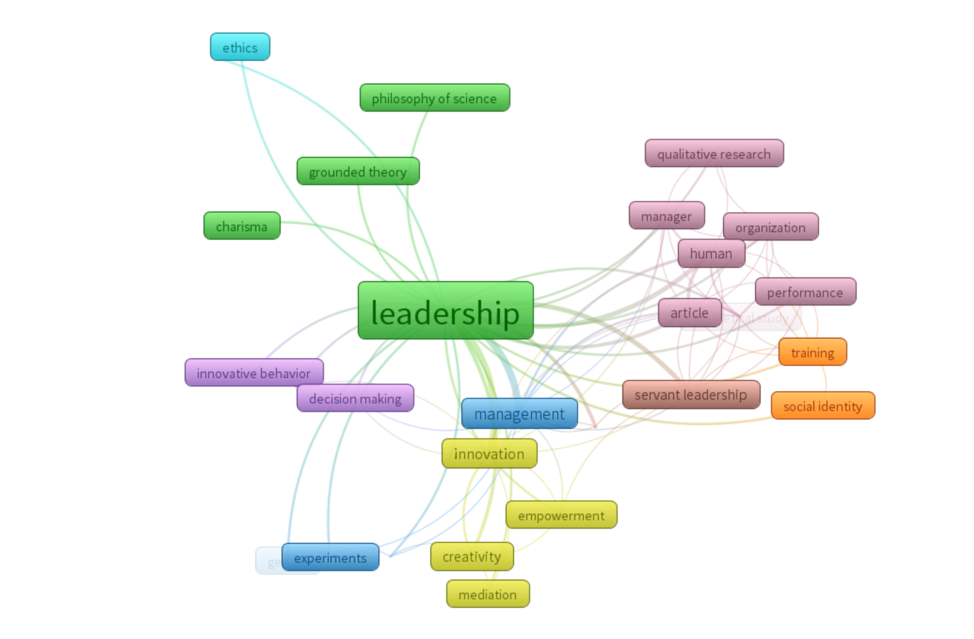Source: own work

Table 1. The number of articles analyzed at the second and third selection stages.
510 articles
identified at the third stage of selecting publications from the SCOPUS database
2010 | 2011 | 2012 | 2013 | 2014 | 2015 | 2016 | 2017 | 2018 | 2019 | 2020
29 | 23 | 29 | 27 | 23 | 28 | 50 | 62 | 75 | 70 | 94
55 articles
ultimately qualified for in-depth analysis
2010 | 2011 | 2012 | 2013 | 2014 | 2015 | 2016 | 2017 | 2018 | 2019 | 2020
5 | 5 | 5 | 6 | 5 | 4 | 5 | 5 | 5 | 5 | 5
Source: own work

Table 2. Leadership definitions in the analyzed articles
Rok |  | Definicja
2010 | Brownell 2010, p. 366) | the act of service to empower followers
2010 | Han, Kakabadse & Kakabadse p. 266 | an urge to serve to ensure that the served grow as persons and their needs are satisfied after Greenleaf 1970, p. 4
2011 | Kempster & Parry 2011, p. 107 | a socially real phenomenon in the sense that if humans did not exist it would not exist after Fleetwood 2004  a social and relational inﬂuence process that occurs within a social system after Parry 1998, p. 87; Hunt 1991; Locke et al. 1991; Yukl, 1998
2011 | Sydow et all 2011, p. 330 | individual and/or organizational action based upon social relationships that make things happen often through inﬂuencing the actions of others via the production and reproduction of structures after Huxham & Vangen 2000, p.1165, see also Bass, 1990
2013 | Kissi, Dainty & Tuuli 2013, p. 486 | leading that changes followers, causing them to look beyond self-interest in favour of the group's objectives by modifying their morale, ideals and values after Pieterse et al. 2010, p. 610
2013 | Hoch 2013, p. 159 | a dynamic interactive inﬂuence process among individuals in groups where they lead one another to the achievement of group/ organizational goals or both after Pearce & Conger 2003, p. 1
2013 | Karakas & Sarigollu, 2013, p. 666 | a paternalistic style of cultural context where leaders show individualized care and concern for subordinates in both work and nonwork domains after Wang & Cheng (2009)
2013 | Driver 2013, p. 418 | an organizational practice that centers on the construction of identities
2014 | Ayoko & Chua 2014 pp. 504-531 | the process of influencing others to accomplish individual, team, and organizational goals after Fu & Yukl, 2000
2014 | Daly et all 2014, p. 77 | the ability to influence peers to act and provide them with support and motivation; a role in organizational strategic direction; challenge processes; and the ability to implement the vision after Garrubba, Harris & Melder, 2011
2014 | Steffens et all 2014, p. 1002 | a capacity to represent, advance, create, and embed a shared sense of social identity for group members after Haslam, Reicher & Platow 2011; Hogg 2001; Reicher, Haslam, & Hopkins 2005; Turner & Haslam 2001; van Knippenberg & Hogg 2003; van Knippenberg, van Knippenberg, De Cremer, & Hogg 2004; Ellemers, de Gilder, & Haslam, 2004; Reicher et al., 2005; Turner, 2005.  In other words, it is a process of social influence that involves making everyone want to contribute to shared goals after House, Javidan, & Dorfman, 2001
2014 | Lewis, Andriopoulos & Smith, 2014, p. 58 | a dynamic competence and a relational process after Augier and Teece 2005, pp. 114-136
2015 | Havermans et all 2015, p. s181 | a dynamic process of dealing with complexity after Uhl-Bien, Marion, & McKelvey, 2007
2015 | Valente, Dredge & Lohmann, 2015, p. 128 | is a process, an outcome, and a concept that is both tangible (such as a formal position) and intangible (such as an experience, a conversation, or the 'soft' power of a charismatic actor) after Bolden, Petrov & Gosling 2009; Chemers, 2014; Tourish, 2014
2016 | Stephan & Pathak 2016, p. 506 | is a process of social inﬂuence to achieve goals after Yukl, 2010
2017 | Fischer, Dietz & Antonakis 2017, p. 1727 | is a social and goal-oriented influence process, happening in a specific time and place and consisting in mediating constructs, such as follower motivation after Antonakis, Day, & Schyns, 2012; cf. Senge, 2014
2019 | Currie & Spyridonidis 2019, p. 1212 | shared roles between members of a leadership team who work together harmoniously, considering the necessary variety of skills, expertise, and sources of influence and legitimacy after Denis et al., 2012
2019 | Cunha et all 2019, p. 706-707 | the ability to switch flexibly between seemingly paradoxical leadership behaviours in order to reconcile conflicting interests and fostering organizational ambidexterity
2019 | Javed et all 2019, p. 556 | an invitation for the contributions of others, after Nembhard & Edmondson 2006, p. 947.
2019 | Eva et all 2019, p. 111 | a holistic approach that engages followers in multiple dimensions (e.g., relational, ethical, emotional, spiritual), such that they are empowered to grow into what they can become.
2020 | Paais & Pattiruhu 2020, p. 579 | a process to influence existing activities, primarily to conduct organizations in groups to achieve initial goals, after Mitchell & Scott, 1987  an encouraging process in pursuing shared goals through successful interaction of various individual differences, after Pigors 1933
Source: own work

Table 3. Dominant components of the term leadership by year
2010 | 2011-2013 | 2013-2015 | 2016-2018 | 2019 | 2020
leader | social relations | impact on followers | objective-oriented influence | cooperation and commitment | incentive-oriented process
Source: own work

