Table 2. Descriptive Statistics (Using Age Group Measure).
Age Group | Dependent Variables | Mean | Std. Deviation | Mean Ranks (Kruskal-Wallis)
Under 20  (n = 29) | LEGO_Att  LEGO_NOST  NOST_PURCH IND_NOST | 4.9310  4.2069  3.1379  3.0690 | .25788  1.01346  1.27403  1.41247 | 153.33  101.34  119.07  106.43
20-29  (n = 73) | LEGO_Att  LEGO_NOST  NOST_PURCH IND_NOST | 4.5068  4.5342  3.1781  3.3151 | .68967  .85118  1.45624  1.26795 | 112.49  128.26  122.79  117.38
30-39  (n = 117) | LEGO_Att  LEGO_NOST  NOST_PURCH IND_NOST | 4.7521  4.7179  3.4530  3.5983 | .53989  .62761  1.47681  1.37126 | 136.00  141.14  137.02  135.04
40-49  (n = 31) | LEGO_Att  LEGO_NOST  NOST_PURCH IND_NOST | 4.5484  4.1613  3.1935  3.6129 | .72290  1.31901  1.57944  1.30837 | 119.08  113.23  124.77  134.48
Above 50  (n = 5) | LEGO_Att  LEGO_NOST  NOST_PURCH IND_NOST | 3.8000  3.8000  2.0000  4.8000 | 1.30384  .83666  1.00000  .44721 | 75.60  62.90  64.90  203.30

Table 3. Kruskal Wallis Test for Significant Differences among Age Groups (SPSS Output).
Test Statistics^{a,b}
 | LEGO_Att | LEGO_NOST | NOST_Purch | Ind_NOST
Chi-Square | 18,590 | 19,364 | 6,576 | 11,124
df | 4 | 4 | 4 | 4
Asymp. Sig. | ,001^{c} | ,001^{c} | ,160 | ,025^{d}
a. Kruskal Wallis Test
b. Grouping Variable: AGE_group
c. significant at p < 0,01
d. significant at p < 0,05

Figure 1. Age variation of the study’s sample (SPSS output).

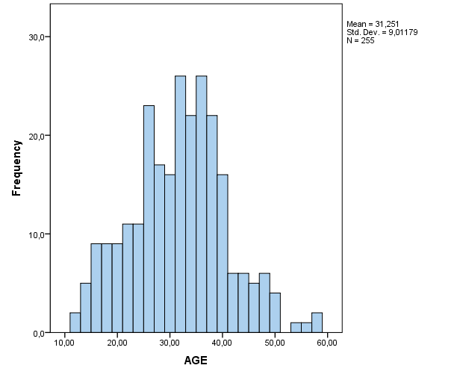
Figure 2. LEGO® customer segmentation by “loyalty” in Poland (SPSS output).

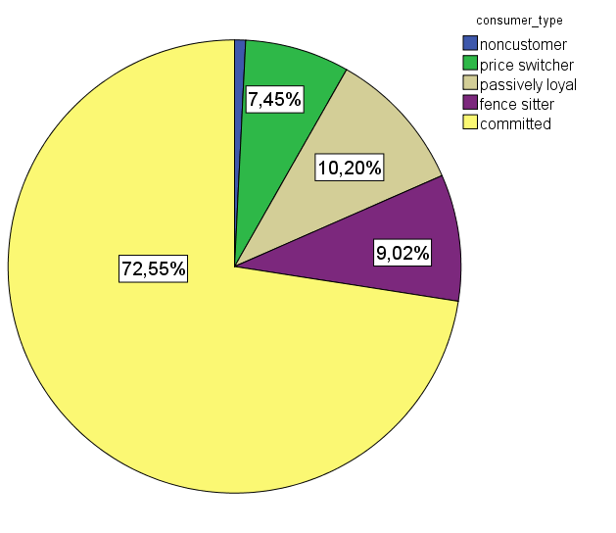

Table 1. Independent Samples T-Test (SPSS output).
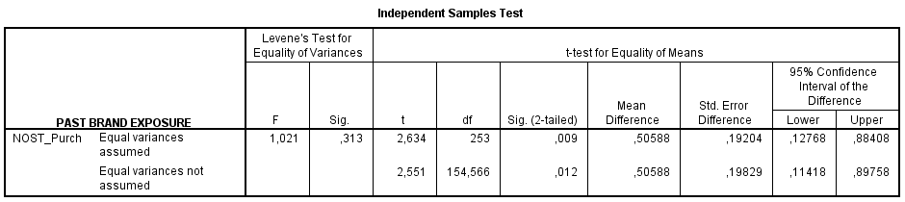

Table 4. Correlation Table for Relevant Data (SPSS output).
