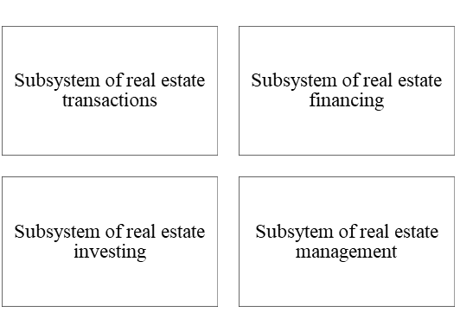
Fig. 2 The real estate market as a system
Source: author’s own interpretation on the basis of: Bryx 2007, p. 88.

