Table 1. Division on SIs and LSIs in Spain.
Significant institutions (SIs) | Less significant institutions (LSIs)
11 Banking Groups (ABANCA Holding Financiero S.A.; Banco Bilbao Vizcaya Argentaria S.A.; Banco de Sabadell S.A.; BFA Tenedora De Acciones S.A.U.; Banco Santander S.A; Bankinter S.A.; CaixaBank S.A.; Banco de Crédito Social Cooperativo S.A; Kutxabank S.A; Liberbank S.A; Unicaja Banco S.A.) | 69 groups of institutions  (mostly cooperative banks)
2 Banks (Banco Mare Nostrum S.A.; Ibercaja Banco S.A.) | 69 groups of institutions  (mostly cooperative banks)
Source: own work based on: https://www.bankingsupervision.europa.eu/ecb/pub/pdf/ssm.list_of_supervised_entities_201802.en.pdf (08.05.2018); Banco de Español, Report on the banking supervision in Spain 2017, https://www.bde.es/bde/en/secciones/informes/Publicationes_an/Memoria_de_la_Su (08.05.2018).

Figure 1. Treatment of SIs in case of failure.
ECB: the bank is assessed as „failing or likely to fail”
SRB (executive session): there are no private solutions to support the bank and resolution is in the public interest
SRB (executive /plenary session): decides about resolution tool and financing (prepares resolution scheme)
Resolution college: Resolution scheme is adopted, amended or SRB decides to act independently
EC: no objections
EC: objections to discretionary elements of the scheme
EU Council: support the EC’s objections as regards use of SRF
EC: objections as regards public interest or use of SRF but refused by EU Council
EU Council: adopts the EC’s objections as regards public interest
SRB: modifies the scheme
FROB: executes the scheme
SRB (executive session): there are no private solutions to support the bank but the public interest is not endangered
Mercantile Court: decides on insolvency proceedings (insolvency administrators proposed by the FROB)
ECB:
Revokes the license
FGDEC:
Pays-out guaranteed deposits

Source: own work.

Figure 2.Treatment of LSIs in case of failure.
Bank of Spain: declares that the bank is „failing or likely to fail”
FROB: decides there are no private solutions to support the bank and resolution is in the public interest
FROB: decides there are no private solutions to support the bank but resolution is not in the public interest
Mercantile Court: decides on insolvency proceedings (insolvency administrators proposed by the FROB)
ECB:
Revokes the license
FGDEC:
Pays-out guaranteed deposits
FROB: prepares resolution scheme (selects resolution tool)
FROB: executes the resolution scheme

Source: own work.
Table 2. Advantages and disadvantages of the crisis management framework in Spain.
Crisis management framework for significant institutions (SIs) | Crisis management framework for less significant institutions (LSIs)
Advantages/benefits: high number of engaged authorities reduces the probability of abuses during resolution; involvement of international bodies which enhances the independency of the process; | Advantages/benefits: procedure is simple and fast; domination of local authorities in the process may foster more immediate reaction to the problems of a bank (as they are closer to the bank); positive incentives for local supervisor to apply best practices, as otherwise it may lose the power to control entities at the benefit of the ECB
Disadvantages/risks: the broad range of engaged authorities and long procedure may delay the actions when rapid and decisive intervention is needed; the authorities that are primarily responsible for resolution are located far away from the failing bank (communication barriers) and do not know the local specificities in the functioning of the institution (specific market and cultural issues); decision-making transferred to the international (pan-European) authorities, but ultimate financial responsibility rests on national resources (national deposit guarantee scheme; national central bank’s liquidity support); | Disadvantages/risks: within mixed framework (separate procedures for SIs and LSIs) there may be a danger of “supervisory/resolution forbearance”, which means that the authorities may seek to delay the intervention in order not to reveal that there are any problems within national banks; lack of the access to the international financing sources (lack of the ECB liquidity support)
The consequence of the double, parallel frameworks for the resolution of Spanish banks may be confusing for investors – as a result standard authorities’ activities may spark panic among market participants as a result of misunderstanding of the framework
Source: own work.
Figure 3. The BPE’s total assets (Panel A) and profits (Panel B).
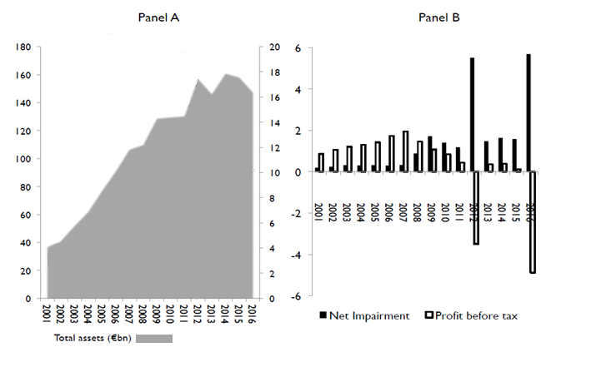
Source: T. Santes, El Diluvio: The Spanish Banking Crisis 2008-2012, https://www.dnb.nl/en/binaries/Tano%20Santos_tcm47-360757.pdf (07.05.2018), p. 102.
Table 3. Criteria for the assessment of Spanish banks’ mergers.
Criterion | Indicator being evaluated (one-year horizon)
Capital adequacy | Capital adequacy ratio
Profitability | Net profits, ROE, ROA
Leverage | Leverage ratio
Cost efficiency | Cost to Income (C/I)
Quality of assets | NPL
Operational efficiency | Information whether the bank continued the provision of its products and services
Source: own work.
Table 4. Results of the quantitative evaluation of the Spanish banks’ mergers.
Indicator being evaluated (one-year horizon) | Successful mergers as percentage of all mergers*
Capital adequacy ratio | 80%
Net profits | 44,12%
ROE | 36,36%
ROA | 27,27%
Leverage ratio | 40%
Cost to Income (C/I) | 57,69%
NPL | 35,71%
Information whether the bank continued the provision of its products and services | 100%
* In the calculation only those mergers were taken into account, for which there was data for the assessment.
Source: own work.

