Content

Abstract 1
Review of Means- End Chain Theory 2
Conventional Means- End Chain Theory 2
Self- Concept Approach Integrated into MEC 4
Behavioural Perspective Model incorporated into MEC 6
New Extended Means- End- Chain (EMEC) Metatheory 10
Conclusions 15
Acknowledgements 15
Bibliography 16

Name of Author: Elena Borgardt
Affiliation: Cracow University of Economics, PhD Candidate
Title of the Article: Extension of Mean- End- Chain Theory by Integrating Self- Concept Approach and Behavioural Perspective Model

Extension of Mean- End Chain Theory by Integrating Self- Concept Approach and Behavioural Perspective Model

Abstract
This methodological and concept paper attempts to combine the recently emerged, yet well- established, value- based, cognitive model – the Means- End chain (MEC) – with the self- concept approach and the Behavioural Perspective Model (BPM).
The aim of the publication is to elaborate the MEC theory, the post- modern approach of self- concept and the hermeneutical model based on radical behaviourism, BPM; reveal the points of contacts and differences with the MEC theory; and formulate a novel extended Means- End chain metatheory.
The theoretical framework is based on the critical view of the scientific books and articles; and includes examination of the elements to enhance the MEC model with symbolism, dynamics and multi-dimensionality on the micro- level, through integration of the self- concept approach; and on the macro- level via incorporation of environmental, reinforcing/aversive and experiential aspects of the BPM.
The results of the investigation pave the way to the new research- frame Extended Means- End Chain – EMEC – that opens up new opportunities for re- designing and re- systemizing of the interpretation and understanding of the consumer behaviour.

Key Words: consumer behaviour, Means- End Chain Theory, self- concept, Behavioural Perspective Model
JEL Classification Code: M30, M31, M37

Review of Means- End Chain Theory
The “Means-End Chain Approach” is an idiosyncratic umbrella term that comprises a myriad of qualitative and quantitative methods to elicit deep, underlying consumer values at different levels of abstraction [Olson & Reynolds 2001].
While there is a good deal of theoretical and empirical literature on this approach, the MEC in its current form seems to reach the limits of the academic development and practical applications. To resolve this dispute, the current paper presents a novel conceptual and methodological framework – EMEC, which outlines promising scenario for the future research.
EMEC enlarges the epistemological status of MEC from the purely cognitive view prevailing in the science today to a more motivational research approach that deals with situational and impetus constructed meanings. Thus, the self- concept approach (micro- level) and the BPM (macro- level) combined with the MEC prove to form synergies and open up new avenues of thought to enhance the model with symbolism, dynamics and multi-dimensionality [Borgardt 2018].

Conventional Means- End Chain Theory
The Means-End chain Theory is a value-based, cognitive model used to better understand consumer behaviour and decision-making. It connects the tangible attributes of a product (the means) to highly abstract and intangible personal and emotional values (the ends) [Olson & Reynolds 2001].
Tom Reynolds and Jonathan Gutman, inspired by Kelly’s work [Grunert & Bech-Larsen 2005, Ferran & Grunert 2007], introduced the Means- End Approach into the field of marketing and consumer research. The scientists postulate the existence of hierarchically organized relationship, connecting product attributes (A), consequences (C) and individual values (V) [Chin-Feng, Hsien-Tang & Chen-Su 2016]. The A-C-V ladder chain provides an understanding of the salient factors and their personal importance to consumers as they make decisions.
The means-end chains is a sequential process that can be assessed in three steps: identification of the salient product attributes, the laddering procedure and analysis of the data and plotting of the HVM.
Salient product attributes that are important for consumers can be identified using techniques based on sorting procedures, elicitation, ranking or scaling tasks. These techniques originate from cultural domain taxonomies and aim to distinguish objects according to their perceived similarities or differences [Olson & Reynolds 2001; Bernard 2011].
The laddering interview identifies “why” particular attributes are important to the consumer in a projected situation, once the most important, salient attributes have been determined.
Laddering is classified into soft and hard techniques. Soft Laddering is applied in research with an exploratory character [Doing Social... 2008] and has a qualitative appeal. Hard Laddering is a more structured, more mechanistic interview model that asks consumers to generate associations [Olson & Reynolds 2001].
The analysis of collected data encompasses a large number of conventional and modern methods which facilitate the interpretation of results originating from laddering (e.g. multivariate methods, regression, structural equation model, etc.).
Hierarchical Value Maps (HVM), also called Consumer Decision Maps (CDM), are an easy-to-interpret, graphical presentation of laddering interviews in the form of a tree diagramme [Olson & Reynolds 2001]. It is constructed based on a summary implication matrix or SIM of aggregated individual ladders [Kaciak 2011; Olson & Reynolds 2001].
Mecanalyst Plus and Laddermap are the most frequently used software to plot HVMs.
Thanks to the wide range of benefits the Means-End chain Theory offers, it has gained in popularity in numerous fields: marketing, with a focus on MECCAS advertising strategies (Means-End Conceptualization of the Components of Advertising Strategy) [Søndergaard 2005; Bech-Larsen 2000]; brand equity analysis [Wansink 2007]; consumer involvement [Lind 2007]; politics [Bagozzi 2000; Phillips, Reynolds & Reynolds 2010]; E- Banking [Kuisma, Laukkanen & Hiltunen 2007] and social networking [Aschmoneit & Heitmann 2002].

Self- Concept Approach Integrated into MEC
Basically, the goal- oriented MEC theory is a comprehensive model and a useful framework for understanding consumer behaviour and decision-making. Yet, in respect to amplitude there are notably a few gaps on the micro- and macro- levels. In such a way, the improvement element on micro- level could be integration of a self- concept approach, where values, which are central to the individual, reflect the awareness and perceptions about oneself and consequently provide an in- depth understanding of consumer’s personality to find new ways to trigger consumer behaviour. On a macro- level, the MEC could obtain dynamics in terms of environmental, reinforcing/aversive and experiential aspects [Borgardt 2017].
Hence, bridging the micro- level (self- concept approach), the MEC and the macro- level (BPM) could introduce a more systematic view in value- based and goal- oriented MEC theory.
Principally, self- concept is a complex notion that has been treated from different theoretical points of view: psychoanalytic or Freudian theory considers the Self as a system of competing forces inflicted with conflict; behavioural theory assigns the Self as a bundle of conditioned responses; cognitive perspective characterises the Self as a system, processing information about the self [Solomon et al. 2008; Proceedings... 2015].
Apart from that, there are still debates ongoing, whether the Self is a uni- dimensional concept, where it is treated as ideal, actual self or extended self; or multidimensional construct, involving variety of notions, thus being individualistic, identity- forming, symbolic and experiential in nature [Blaiech, Gharbi & Hamouda 2013].
Following Hirschman’s and Holrbook’s view [Hirschman & Holbrook 1982], representatives of post- modern marketing, personality and values are tightly correlated and in that sense:
- value is an interaction between a subject (individuum) and an object (product) and values are changeable across individuals;
- purchase of goods by a person is not considered from neoclassical, utility perspective, but from experience standpoint [Sánchez-Fernández & Iniesta-Bonillo 2007];
- an individual prefers products with images congruent with the self- concept (self- congruent products);
- a person is directed to enhance the self- concept/identity through products, communicating symbolic meaning;
- moreover, the personal values are comparative and situational [Holbrook 1999].
Going deeper into the comprehensive Typology of Consumer Value approach proposed by Holbrook [Holbrook 1996, Holbrook 1999], it is worth mentioning three key dimensions of consumer/personal values, which will be further interrelated with the MEC Theory:
- extrinsic (consumption is appreciated for its instrumentality as means to ends relationship) versus intrinsic value (consumption experience as an end in itself);
- self-oriented (prizing of values for person’s own sake) versus other-oriented value (consumption beyond the self to someone else);
- active values (physical or mental manipulation of a product) versus reactive (an experiential impact the product has on a consumer) [Sánchez-Fernández & Iniesta-Bonillo 2007; Holbrook 1999].
Yet, other post- modern adherents underline additional concepts, called the “multiphrenic self”, the existence of different personalities/identities in the same individual at a period of time, which could lead to contradictory and paradoxical behaviours. Meaning that post- modern individual looks for the multiplicity of images and personalities to better adapt to the situations [Hamouda 2012].
Mentioned above holistic, post- modern marketing view of self- concept could be considered as an interesting opportunity for integration into the MEC Theory.
Obviously, the basic assumptions of both input models coincide with each other: connection of the product attributes (the means) with personal and emotional values (the ends) [Olson & Reynolds 2001]. Apart from that, the key dimensions of consumer/personal values elaborated by Hirschman and Holbrook are interwoven with the MEC stance. The only exception is that the MEC analysis provides a way of linking consumption to values indirectly, without clear consideration of experiential end-in-itself in the process [Holbrook 1999].
Besides, the MEC sufficiently depicts the affect between consequences of consumption and consumption values, however the connection of higher order consumption value is equivocal interlinked with personal values [Holbrook 1999].
When it comes to consideration of the Self in a situational context, the MEC “specific” and “broad” approaches with projection of situation in cognitive structure of a consumer [Grunert, Grunert & Sørensen 1995] cold be considered as static and simplistic, with a fixed number of values at the end of the chain. "Multiphrenic self” in post- modern view, on the contrary, is dynamic and could be driven by several, differentiating goals to satisfy the personalities/identities in place [Hamouda 2012].
As pointed out by Rokeach [Rokeach 1973], it is very rare that any situation encountered in life will activate a single value. Most situations will involve a conflict among several values to be resolved in accordance to the person's value priorities, or value system [Kamakura & Novak 1992].
Thereof, the value- based and goal- oriented MEC Theory in combination with postmodern self- concept (micro- level) marketing approach with its multi-faceted vision of symbolism, unique meanings, feelings, experience, and pleasure, are necessary to re-design and re- systemize the interpretation and understanding of consumer behaviour and decision- making process within the MEC framework.

Behavioural Perspective Model incorporated into MEC
Cognitive theories with emphasis on mental structures and thinking processes are very motivating and manoeuvre- free in explaining consumer behaviour; yet, behavioural approaches, emphasizing the direct link between the environment and the individual’s behaviour, increase the predictability and control of consumer behaviour and could be a promising enhancement instrument in the consumer behaviour and marketing [Foxall et al. 2006].
The BPM is a hermeneutical model based on radical behaviourism, Skinner’s operant conditioning and single- subject research strategy [Foxall 2004].
Foxall describes the model as “the rate at which consumer behaviours take place as a function of the relative openness of the setting in which they occur and the informational and utilitarian reinforcement available or promised by the setting” [Foxall 2007].
In focus of the model are situational variables in determination of behaviour, with specific focus on antecedent events and forthcoming responses of an individual. Hence, the BPM is a three- term contingency model, consisting of discriminative stimulus, response and reinforcing or punishing/aversive consequences: S^{D} →R →S^{R/P} [Foxall et al. 2006].
In line with the BPM model, consumer behaviour is located at the intersection of a consumer-behaviour setting and an individual’s learning history of consumption and is a function of utilitarian and informational reinforcements [Foxall et al. 2006].
According to the BPM, consumer behaviour and with it the rate of consumer response (dependent variable) is determined by consumer- behaviour setting (antecedent variable), which could vary in the scope from relatively closed to relatively open.
The consumer- behaviour setting could be divided into physical, social, temporal (time- based) and regulatory (rule- based) antecedent discriminative stimuli [Foxall 1998]. Consumer behaviour in relatively closed situations, with limited number of alternatives/reinforces, tends to be compliant with established directives to avoid the aversive consequences (e.g. casino gambling); hence making the emission of the response more predictable and under greater control. Relatively open settings, lessen the likelihood to foresee the consumer’s behaviour, due to greater choice, self- motivation and guidance by positive reinforces (e.g. supermarket purchase).
Consumer behaviour, in its turn, creates bifurcation of utilitarian and informational reinforcements (independent variable), which can be both reinforcing and aversive.
Utilitarian reinforcements refer to technical functions of a product and reflect the value-in-use, as well as feelings associated with owning and using the product. (e.g. arousal, sensory stimulation, enjoyment). Utilitarian reinforces, can be both primary and secondary in nature, and are also considered as contingency- derived [Foxall 1998].
Informational reinforcements are symbolic, socially-determined functions, akin to exchange value, which generate incentives, affecting the behaviour of other people. (e.g. feedback on the individual’s achievement, social acceptance or social status). Informational reinforces, secondary in nature, are also called rule- derived reinforces and responsible for emission of rule- derived behaviour [Foxall 1998].
Synthesis of utilitarian and informational reinforces as well as pairing of primary and secondary stimuli configurate the consumer’s unique learning history [Foxall 2009].
Aversive consequences are generally leading to the extinction of a behaviour. (e.g. costs connected with purchase, pollution of environment as a results of driving car, etc.)
The individual’s learning history refers to the experience obtained in the comparable situations in the past, which was either reinforced or weakened, influencing the likelihood of reoccurrence of the behaviour in the future occasions.
Taking into account the combination of consumer- behaviour setting (relative open vs. relative close) and operant classes (formed by means of pairing high/low utilitarian with high/low informational reinforces), Foxall has elaborated eight contingency categories, which help to understand the complex nature of the behaviour.
A very interesting phenomenon is that operant classes (i.e. accomplishment, hedonism, accumulation and maintenance) are also considered as equifinality classes; meaning that topographically different responses belong together due to their equal functionality and therefore produce identical consequences [Foxall 2009].
Table #1: The BPM Contingency Matrix
The table below is adapted and modified from Foxall [Foxall et al. 2006; Foxall 2009].

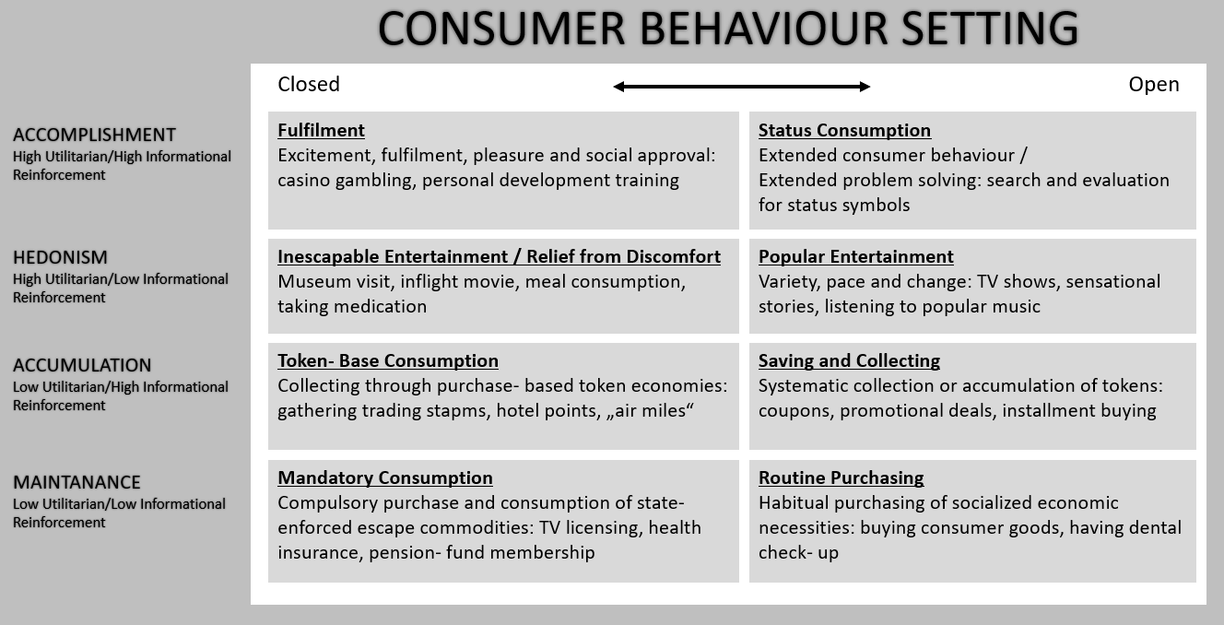

Table #1 illustrates four operant classes of consumer behaviour on the left- side of the graph, divided according to the pattern of reinforcement (i.e. high/low utilitarian and high/low informational).
The operant classes, in their turn, can be operationalized alongside the scope of the setting (i.e. relatively open behaviour setting vs. relatively closed behaviour setting) to build eight contingency categories to classify the behaviours. Digest of each contingency category with corresponding examples are depicted in the center of the picture.

Obviously, the immediate intersection of the MEC and the BPM are reinforcements, dealing with values (utilitarian, informational), which could serve as a starting point for the models’ fusion.
Situational context, learning history and consumer behavioural dynamism mentioned in the BPM could be considered as conceivable enhancement elements of the MEC Theory on the macro- level.
As previously mentioned, the MEC Theory is based on cognitive approach, dealing with input, latent variables; whereas the BPM implicitly comprises the elements of cognitive mechanisms, handling unobservable variables as well as covers input and output variables, observable variables, which could positively contribute to exposure of the MEC Theory.
Compared to the MEC Theory, the BPM illustrates the consumer behaviour, as a comprehensive, dynamic mechanism, depending on the situational context. The point of activation of the consumer’s cognitive structure by situational factors in the MEC, however, still requires further investigation. Apart from that, information produced during the laddering interviews in its standard form does not allow to reflect the situational specificity the respondents have in mind [Olson & Reynolds 2001]. Therefore, the merger of both theories could lead to new findings in the consumer behaviour area.
A consumer, driven by the learning history, including episodic information (previous key experiences with products that are linked to a specific time, space) [Olson & Reynolds 2001], could be conflicted by a few outcome scenarios: either approaching valued desired end- states or avoiding undesired end- states. The point is that the MEC perfectly elucidates the positive values on the Hierarchical Value Maps (HVM), whereas the HVM based on negative laddering could completely omit the values’ representation, although the discoveries about reverse values could be of an interest for the researcher or marketer for the analysis and product strategy [Zanoli & Naspetti 2002].
The further appealing investigation point is of equifinality, whether it will still retain its “finality” status while integration into the MEC; or it will gain the character of a starting point in the re- defined, dynamic MEC chain.
In sum, the combination of the value- based MEC theory and the stimulus- response BPM model could lead to increasing the overall understanding of consumer behaviour by providing new perspective on the meaning of purchase and consumption.

New Extended Means- End- Chain (EMEC) Metatheory
As it is vivid from the paper, consumer behaviour is a constantly evolving realm of marketing, striving to understand and explain consumer behaviour. And although cognitively- based approaches, prevailing over the last decades, possess high predictability of consumer behaviour, there is still potential to complement them with new, unconventional approaches.
As it was previously depicted, the MEC is a value- based theory with a well- grounded and in- depth illustration of behaviour as a cognitive process, involving various levels of associations (A- Attributes, C- Consequences and V- Values) [Reynolds & Olson 2001]. These levels, merged in the memory, provide a consumer with the personal impetus to direct behaviour toward the goal’s achievement.
Since the MEC explains behavioural intention once the relevant excerpts from cognitive structure and motivation are known [Olson & Reynolds 2001], it could be considered as an output tool only.
Consequently, symbolism, experience and feelings, originating from the self- concept; as well as the manipulation of the environments, in which the response and reward occur, are the missing building blocks that could explain, how in a given situation and under given motivational constraints certain parts of cognitive structure become relevant, thus bringing dynamics into the MEC.
Table #2: Extended Means- End- Chain (EMEC) Constellation
Source: the author
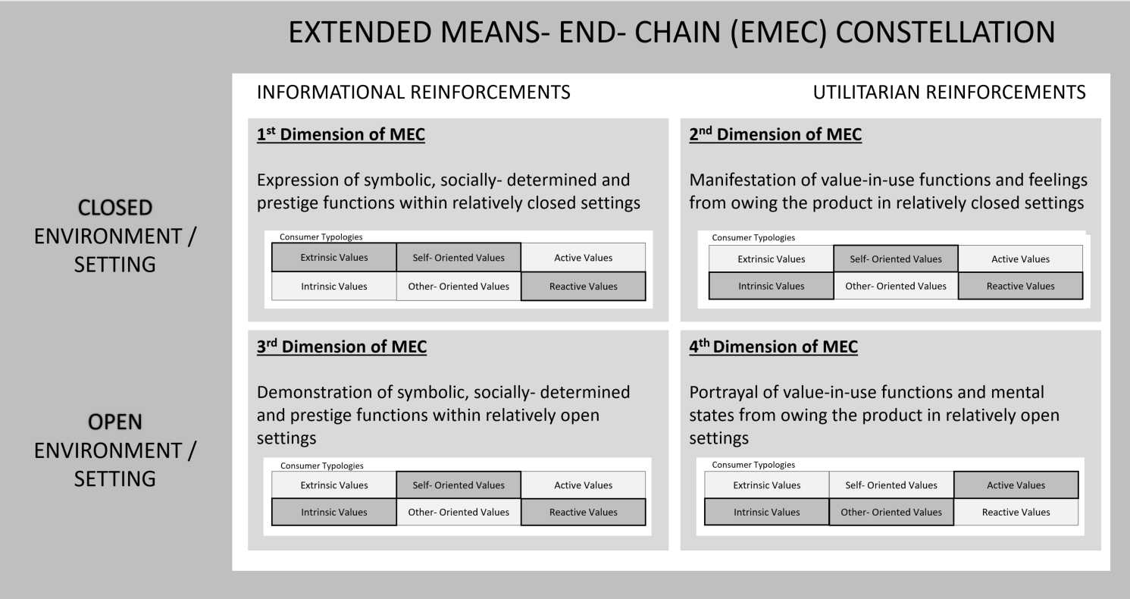
Table # 2 portrays new EMEC model, where the goal- oriented MEC is crossed with the BPM model, generating 4 dimensions: informational and utilitarian reinforcements are opposed to relatively closed versus relatively open settings/ environments.
Apart from that, as it was emphasised, personality is the core element of an individual, influencing the behaviour. Individuals, searching for self- congruent, identity- forming products, are directed by symbolic and experiential values concealed in the product during the decision- making process. In that way, the MEC could be also filled in with the self- concept variables to bring holistic, experiential aspect into the model.
Hence, 4 MEC dimensions, as a cross- section of the MEC and the BPM, are extended to 6 sub- categories each (extrinsic vs. intrinsic values; self- oriented vs. other- oriented; active values vs. reactive values), coming up to new 24 sub- dimensions, defining the consumer typologies, of the EMEC in total.
Yet, although all consumer typologies could come into place simultaneously, not all of them are equally pronounced. Hence, Table #2 distinguishes between supreme/primary (marked in saturated grey color) and subordinate/secondary (marked in pale grey) consumer typologies, becoming relevant under effect of informational/utilitarian reinforcements and closed/open settings.
Consequently, the 1st Dimension of MEC (informational reinforcements opposed to closed setting) defines extrinsic, self- oriented and reactive values as supreme ones; where intrinsic, other- oriented and active values are subordinate values.
- Thus, gathering tokens/points to obtain a special gift or prize, being admired or praised by the closed society, drinking tea in an exclusive cafeteria, personal development training, etc. could be considered as: means to the accomplishment of specific goals viewed as desirable (→ extrinsic nature);
- selfish or prudent appraisal of some aspect of consumption, for my own sake, infers orientation on the self (→ self- orientation);
- and apprehending, appreciating and admiring result of consumption on consumer points refer to the reactive nature of values being activated (→ reactive values).
Visiting a museum, taking medication, watching in- flight movies, reading sensational literature, etc. are examples of the 2nd Dimension (utilitarian reinforcements contrasted to closed setting); where intrinsic, self- oriented and reactive values are predominant along with secondary extrinsic, other- oriented and active values.
- The intrinsic nature of these activities is comprised in its self-justification, consumption experience as an end in itself (→ intrinsic values);
- self- orientation becomes apparent via effect the event has on the person or contribution to my own experience (→ self- oriented values);
- product’s affect on the consumer depicts its reactive character (→ reactive values).
The 3rd Dimension (informational reinforcements opposed to open setting) outlines intrinsic, self- oriented and reactive values as primary values; where extrinsic, other- oriented and active values play secondary role. Thus, being on holidays, impressive investment in real estate, gesture/feedback in a publicity, payment prior consumption, etc. are a few examples of this dimension.
The illustrations of the 4th Dimension (utilitarian reinforcements contrasted to open setting) could be possession of the luxury car, search and evaluation for status symbols, feelings associated with owing/consuming of a prize, etc. The supreme values in this dimension are intrinsic, other- oriented and active values; at the background are extrinsic, self- oriented and reactive values accordingly.
To sum up, the 1st Dimension and the 4th Dimension present the inversion of one another; whereas the 2nd and the 3rd Dimensions emphasize the same sub- dimensions.
Table #3: New EMEC Metatheory
Source: the author
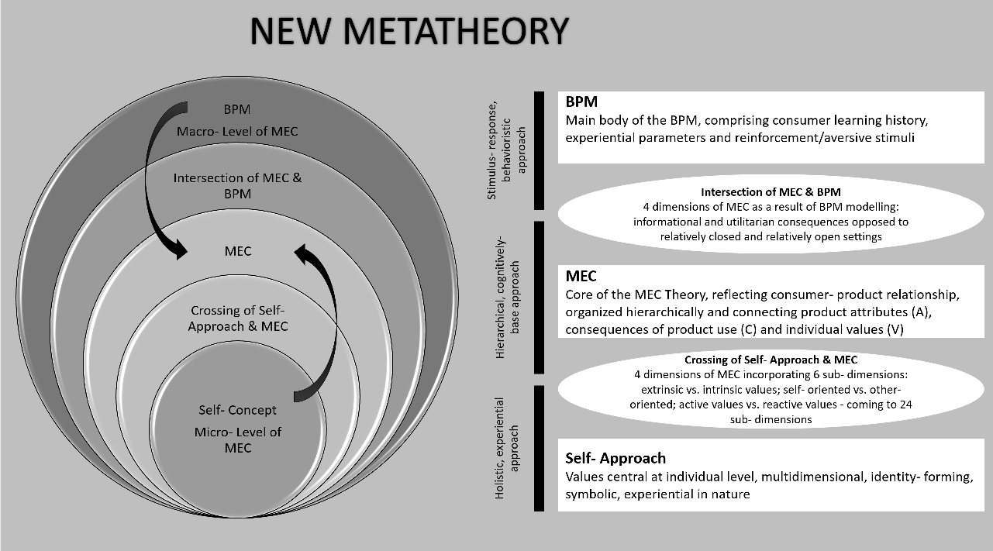

Table #3 represents the graphical summary of the new multi- facet metatheory, where the MEC theory is centralized, as the core of the new metatheory; the self- concept approach, from micro- level perspective, provides an in- depth understanding of consumer’s personality; on a macro- level, with the help of the BPM, the MEC obtains dynamics in terms of environmental, reinforcing/aversive and experiential aspects. The original models, used for formation of the new EMEC theory, are put into rectangles on the right- hand side of the picture. Intersections of the approaches are marked by ovals, making the new elements of the EMEC more obvious.
Based on the new representation of the model shown above, the MEC Theory seems to obtain a full- scaled, dynamic character; yet the issues that are still to be investigated are the causality between the mentioned elements; which of them to be considered as exogenous and which of them refer to endogenous variables; as well as whether there is a direct connection between them or there should be taken into consideration any mediator and/or moderator variables.
In a nutshell, only after examination of all mentioned above aspects, there is a potential for making a significant contribution to consumer research, prediction of behaviour as well as a development of successful product positioning and advertising.

Conclusions
The present publication has attempted to conduct a detailed analysis of the Means- End Chain theory, the post- modern approach of the self- concept and the hermeneutical model based on radical behaviourism, BPM; revealed the points of contacts and differences with the conventional MEC theory; and formulated a new unconventional EMEC metatheory.
Although MEC has proven an effective tool for predicting consumer behaviour, there have been discovered a few gaps on the micro- and macro-levels which the theory does not cover.
As a result, it was proposed a novel, post- modern approach to the Means- End chain Theory – EMEC – eliciting 4 MEC dimensions, as a cross- section of the MEC and the BPM, which are further extended to 6 sub- categories of the self- concept each, coming up to new 24 sub- dimensions, defining the new consumer typologies of the EMEC in total.
Owing to the novel EMEC metatheory, the paper opens new directions for theoretical and practical research involving the use of the MEC in prediction of consumer behaviour, development of successful products and advertising.

Acknowledgements
The author would like to express gratitude to Professor Adam Sagan for guidance, essential comments and advice on earlier drafts of this paper.

Bibliography
Søndergaard A. H. [2005], Market-oriented New Product Development: How Can a Means-end Chain Approach Affect the Process?, “European Journal of Innovation Management”, vol. 8, no. 1, https://doi.org/10.1108/14601060510578583.
Aschmoneit P., Heitmann M. [2002], Customer Centred Community Application Design, Introduction of the Means-end Chain Framework for Product Design of Community Applications, “The International Journal on Media Management”, vol. 4, no. 1, https://doi.org/10.1080/14241270209389976.
Bagozzi R. P. [2000], Discursive Psychology: An Alternative Conceptual Foundation to Means-end Chain Theory, “Psychology & Marketing”, vol. 17, no. 7, https://doi.org/10.1002/(SICI)1520-6793(200007)17:7<535::AID-MAR1>3.0.CO;2-H.
Bech-Larsen T. [2000], Model-based Development and Testing of Advertising Messages – A Comparative Study of Two Campaign Proposals Based on the Meccas Model and a Conventional Approach, “International Journal of Advertising. The Review of Marketing Communications”, vol. 20, no. 4, https://doi.org/10.1080/02650487.2001.11104908.
Bernard H. R. [2011], Research Methods in Anthropology: Qualitative and Quantitative Approaches, 5 ed., AltaMira Press, UK.
Blaiech R., Gharbi A., Hamouda M. [2013], Postmodern marketing: towards a convergence between the individualistic approach and the tribal approach, Interdisciplinary Journal of Contemporary Research in Business, vol. 4, iss. 9.
Borgardt E. [2017], Motivation and Consumer Behavior, “Konsumpcja i Rozwój”, no. 4(21).
Borgardt E. [2018], Conventional and Extended Versions of Means-end Chain Theory, “Zeszyty Naukowe”, Cracow University of Economic Press, no. 3(975), https://doi.org/10.15678/ZNUEK.2018.0975.0312.
Chin-Feng L., Hsien-Tang T., Chen-Su F. [2016], A Logic Deduction of Expanded Means-end Chains, “Journal of Information Science”, vol. 32, no. 1, https://doi.org/10.1177/0165551506059218.
Doing Social Psychology Research [2008], G. M. Breakwell (ed.), The British Psychological Society, Blackwell Publishing, Oxford.
Ferran F., Grunert K. G. [2007], French Fair Trade Coffee Buyers’ Purchasing Motives: An Exploratory Study Using Means-end Chains Analysis, “Food Quality and Prefer- ence”, vol. 18, no. 2, http://doi.org/10.1016/j.foodqual.2005.11.001.
Foxall G. R. [1998], Radical Behaviourist Interpretation: Generating and Evaluating an Account of Consumer Behaviour, “The Behaviour Analyst”, no. 21(2).
Foxall G. R. [2004], Consumer psychology in behavioural perspective, Beard Books, Washington DC.
Foxall G. R., Oliveira-Castro J. M., James V. K., Yani-de-Soriano, M. et al. [2006], Consumer behaviour analysis and social marketing: the case of environmental conservation, “Behaviour and Social Issues”, vol. 15, iss. 1, https://doi.org/10.5210/bsi.v15i1.338.
Foxall G. R., Oliviera- Castro J. M., James V. K., Schrezenmaier, T. C. [2006], Consumer Behaviour analysis: the case of brand choice, rPOT, vol. 6, iss. 1.
Foxall G. R. [2007], The behavioural economics of brand choice, Palgrave Macmillan, UK, https://doi.org/10.1057/9780230596733.
—— [2009], Interpreting consumer choice: The behavioural perspective model, 1 ed., Routledge Interpretive Marketing Research, New York.
Grunert K. G., Grunert S. C., Sørensen E. [1995], Means- End Chains and Laddering: An inventory of problems and an agenda for research, MAPP, Working Paper Number 34.
Grunert K. G., Bech-Larsen T. [2005], Explaining Choice Option Attractiveness by Beliefs Elicited by the Laddering Method, “Journal of Economic Psychology”, vol. 26, no. 2, https://doi.org/10.1016/j.joep.2004.04.002.
Hamouda M. [2012] Postmodernism and Consumer Psychology: Transformation or Break?, “International Journal of Academic Research in Business and Social Sciences”, vol. 2, iss. 1.
Hirschman E. C., Holbrook M. B. [1982], Hedonic Consumption: Emerging Concepts, Methods and Propositions, “Journal of Marketing”, vol. 46, iss. 3.
Holbrook M. B. [1996], Special Session Summary Customer Value C a Framework For Analysis and Research, “Advances in Consumer Research”, vol. 23.
Holbrook M. B. [1999], Consumer value: A framework for analysis and research, 1 ed., Routledge, London, New York.
Kaciak E. [2011], Market Segmentation Based on Consumer Cognitive-motivational Structures, “Konsumpcja i Rozwój”, no. 1.
Kamakura W. A., Novak T. P. [1992], Value-System Segmentation: Exploring the Meaning of LOV, “Journal of Consumer Research”, vol. 19, iss. 1.
Kuisma T., Laukkanen T., Hiltunen M. [2007], Mapping the Reasons for Resistance to Internet Banking: A Means-end Approach, “International Journal of Information Management”, vol. 27, no. 2, no. 5, https://doi.org/10.1016/j.ijinfomgt.2006.08.006.
Lind L. W. [2007], Consumer Involvement and Perceived Differentiation of Different Kinds of Pork – A Means-end Chain Analysis, “Food Quality and Preference”, vol. 18, no. 4, https://doi.org/10.1016/j.foodqual.2006.10.004.
Olson J. C., Reynolds T. J. [2001], Understanding Consumer Decision Making: The Means- end Approach to Marketing and Advertising Strategy, Routledge, New Jersey.
Phillips J. M., Reynolds T. J., Reynolds K. [2010], Decision-based Voter Segmentation:
An Application for Campaign Message Development, “European Journal of Marketing”, vol. 44, no. 3/4, https://doi.org/10.1108/03090561011020444.
Proceedings of the 1993 World Marketing Congress [2015], M. J. Sirgy, K. D. Bahn, T. Erem (eds), Developments in Marketing Science: Proceedings of the Academy of Marketing Science, Springer, Cham–London.
Rokeach M. [1973], The Nature of Human Values, Free Press, New York.
Sánchez-Fernández R., Iniesta-Bonillo M. Á. [2007], The concept of perceived value: A systematic review of the research, “Marketing Theory”, vol. 7(4), https://doi.org/10.1177/1470593107083165.
Solomon M., Bamossy G., Askegaard S., Hogg M. K. [2008], Consumer Behaviour: A European Perspective, 3rd ed., Pearson Education, Harlow.
Søndergaard A. H. [2005], Market-oriented New Product Development: How Can a Means-end Chain Approach Affect the Process?, “European Journal of Innovation Management”, vol. 8, no. 1, https://doi.org/10.1108/14601060510578583.
Wansink B. [2007], Using Laddering to Understand and Leverage a Brand’s Equity, “Qualitative Market Research: An International Journal”, vol. 60, no. 4, https://doi.org/10.1108/13522750310470118.
Zanoli R., Naspetti S. [2002], Consumer Motivation in the purchase of organic food. A means- end approach, “British Food Journal”, vol. 104, iss. 8, https://doi.org/10.1108/00070700210425930.

The utilitarian reinforcement of buying a car is the benefit of owning and using it, in a purely utility and hedonic sense: door-to-door transportation, minimum weather exposure, flexibility, etc.
The informational reinforcement of owning a car could be associated with the social status, prestige and admiration of others. (e.g. Bentley or Mercedes)
Ordering a perfume online and buying it at a specialized store refer to the same equifinal class due to the same outcome. Yet, when two consumers entered the store at the same time and the same manner, their responses will belong to different operant classes, as the one is reinforced by product purchase per se, where the other one is looking for information about quality and price of the product.

