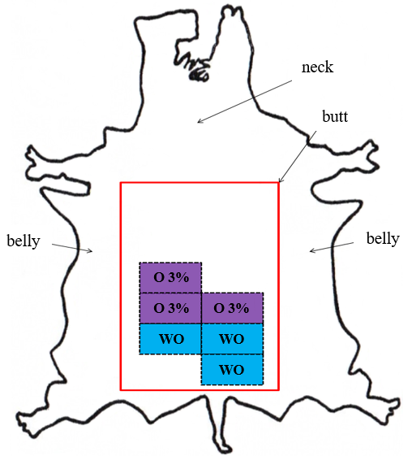
O 3% – samples to be fatliquored with the addition of 3% oregano oil;
WO - samples to be fatliquored without addition of the oil.

Figure 1. Places from which original samples were taken
Source: own research, cowhide leather shape based on [Mięso – podstawy… 2011].

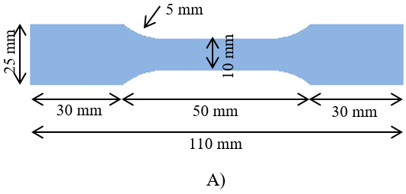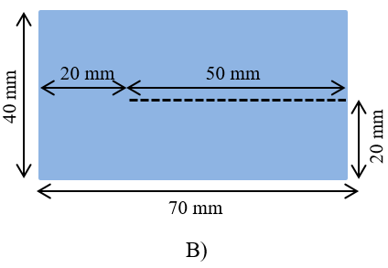
Figure 2. Shapes and sizes of tensile strength and percentage elongation test specimens (A), tear load, single edge tear test pieces (B)
Source: own research based on [PN-EN ISO 3376:2012, PN-EN ISO 3377-1:2012].

